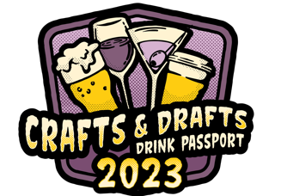

2023 Crafts & Drafts Passport – Campaign Overview

- Crafts & Drafts is a VCOS-sponsored marketing campaign to tell the story of the Colorado Springs & the Pikes Peak Region’s craft beverage scene and drive traffic to participating locations.
- The campaign is funded by VCOS ($75,000), and our participating partners (deals and discounts).
- The campaign kicks off on Monday, May 15, 2023.
- The centerpiece of the campaign is the FREE digital Passport.
- Users will go to VisitCOS.com/passport to sign up for the Passport and receive instructions on how to easily add an icon to their phone’s home screen for quick and easy access to the Passport.
- Each participant is providing a deal/discount/experience – users will ask your servers to redeem the deal by showing the Passport to the server. Once the server verifies the date of redemption, they’ll know to give the guest the appropriate deal or discount.
- Participants must honor the Passport deals & discounts through 12/31/2023.
- Visitors will not be able to access the Passport after 12/31/2023 and participants are not obligated to honor the deals and discounts after that date. This end date is clearly noted in the Passport.
- Please contact us if you have any questions or concerns!

Melissa@VisitCOS.com or 719.685.7641.

